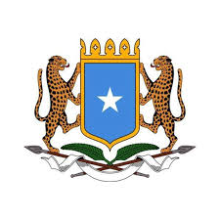
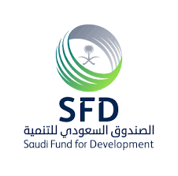
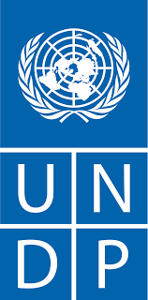

Project Proposal

Project Title: Sustainable Access to Water for Rural communities

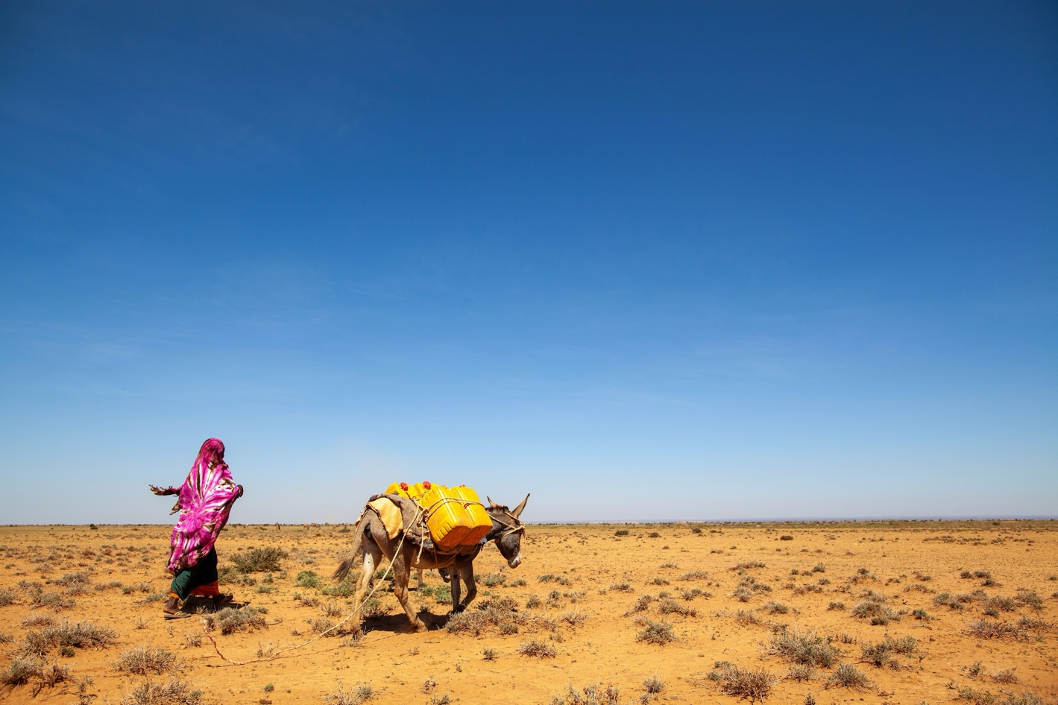

SUBMITTED BY
United Nations Development Programme (UNDP) and Ministry of Energy and Water Resources (MoEWR), Federal Government of Somalia.

Project name | Sustainable Access to Water for Rural Communities
Project objective | The project aims to enhance access to sustainable water resources in 10 drought-affected communities in Somalia through the drilling of wells and the establishment of community-owned and managed water facilities.
Submitting (Lead) Ministry | Ministry of Energy and Water Resources (MoEWR) in partnership with the United Nations Development Programme
Other Federal Ministries coordinated with | Agriculture and Irrigation, Livestock, Forestry and Rangeland, Humanitarian Affairs and Disaster Management, Planning, Investment and Economic Development
Others | Water management authorities and institutions at Federal Member States (FMS)
Submitted to | Saudi Fund for Development (SFD)
Date of initial submission | 14 August 2024
Timeframe | October 2024 – March 2026 (18 month period)
Total Budget | 2,000,000.00 USD
Project Focal Person | UNDP:  Lionel Laurens, Resident Representative UNDP Somalia  Common Compound, Airport Road,  Mogadishu, Somalia  lionel.laurens@undp.org  And  MOEWR:  Abdullahi Hassan Aaden, Director General  Ministry of Energy and Water Resource (MoEWR)  Federal Government of Somalia (FGS)  3rd floor, Mogadishu GPO Building, Bondhere District  dg@moewr.gov.so  + 252 611635330

Table of Contents
A. Background/Developmental Context 5
B. Problem Diagnosis 5
B.1 Problem Statement 5
C.1 Project justification 7
C.2 Project Location and sites 7
C.3 Alignment with the National Water Resource Strategy Roadmap 8
C.4 Project Objectives 9
E. Detailed Budget 14
H. Project Workplan 21
Annex-I : Beneficiary Estimations 23
Annex-2: Sample Technical Drawings 24
Annex-III : Communication and Visibility Plan 25

Background/Developmental Context
Sustainable water management is a crucial national agenda for Somalia, as part of the nation-building efforts. Water plays a pivotal role in supporting livelihoods and various socio-economic activities. However, the availability of water for human consumption and productive use in Somalia is increasingly constrained due to climate variability, prolonged conflict, and the absence of institutions for proper development and management of water resources across the country. Climate change and environmental degradation further exacerbate the pressure on the limited resources. Therefore, it is imperative to strengthen the governance of the water sector for the proper development and management of water resources across the country.
Access to water in Somalia is predominantly connected to land rights and tenure. With major concentrations of population and economic activity in water-scarce, conflict-ridden arid, and semi-arid areas, water crisis due to climate change threatens to reverse the gains in peace and development. Conflicts between farmers and pastoralists are common due to the lack of clear policies on water rights. Women especially Internal Displaced and headed household, girls, people with disabilities (PWD) are particularly vulnerable as they hold the primary responsibilities to collect and store for drinking and household purposes. To build a safe future for all in Somalia, water security must be given higher priority in the national development agenda. As a major partner of the Government in water sector development, UNDP has been engaged to develop National Water Strategy of Somalia which was successfully launched last year. The implementation of the water strategy calls for a whole-of-government approach at the national and a community-based approach at the local level.
The Federal Government of Somalia is committed to ensuring that the water resources of the country are protected, conserved, sustainably developed, and preserved through proper management processes and negotiated allocations. The strategic approach to this has been outlined in the country’s first National Water Resource Strategy, with the strategy being underpinned by a roadmap for implementation.

Problem Diagnosis

B.1 Problem Statement
Somalia's arid climate, characterized by low and unpredictable rainfall, has led to a scarcity of freshwater resources. As a result of the civil war, a lack of community organisation and weak public institutions, water infrastructure has not been maintained or repaired and is extremely deteriorated. Lacking access to watering and irrigation infrastructure for agriculture and livestock is threatening the ability of these sectors to recover and respond to increasingly extreme and frequent droughts.

In Somalia, less than 30% of the population has access to clean water, making it the worst country among all the Arab states in terms of access to drinking water. During droughts, communities are forced to buy water from traditional water catchments known as berkads. For rural households, getting water from these berkads can cost up to USD 6 per day. This is a significant burden for households, especially considering that 73% of the country's population lives below the poverty line and earns less than USD 1.25 per day. In addition to the financial strain, the water facilities are also located far from households, increasing the burden on women girls and boys who are responsible for fetching water. In rural Somali communities, fetching water can take up to an hour, and this trip is often required 5 to 6 times per day to meet the water needs of families and livestock.
The drought impact is reflected in the extent and nature of vulnerability and poverty and the increased risk of falling into poverty, losing autonomy and facing increased discrimination and marginalization. Droughts also negatively affect the traditional roles of older people, and perhaps more specifically their social position, as communities and power and support structures are dismantled, leaving older people with less influence and power.

In Somalia, the urgent need to support drought-affected communities with robust water infrastructure and facilities cannot be overstated. Prolonged periods of drought have severely compromised access to clean water, exacerbating food insecurity and threatening the livelihoods of vulnerable populations. Establishing and enhancing water infrastructure, such as boreholes and water distribution systems, is critical to ensuring that these communities have reliable access to safe drinking water. This support not only addresses immediate health needs but also fosters resilience against future climate challenges, enabling communities to stabilize their livelihoods and improve their overall well-being in the face of recurrent droughts. Immediate action is essential to mitigate the ongoing humanitarian crisis and promote sustainable development in the region.

The use of shallow tubewells for water supply in drought-prone communities in Somalia is inadequate for ensuring year-round access to water. These tubewells often fail to provide a reliable source during extended dry periods, leaving vulnerable communities at risk of water scarcity. In contrast, well drilling or the installation of boreholes is recommended as a more sustainable alternative. Boreholes tap into deeper aquifers, ensuring a consistent and dependable water supply, even in times of prolonged drought. This approach not only meets the immediate needs of the communities but also supports their long-term resilience against climate variability, thereby safeguarding their health and livelihoods.

The National Water Resources Strategy (NWRS) requires a phased approach to achieve sustainable outcomes in Somalia. A roadmap has been developed to outline key priorities, actions, roles, responsibilities, and targets. The roadmap emphasizes the need for cooperative platforms to support and guide actions, oversee progress, and evaluate outcomes. Efforts in the water sector have been fragmented, lacking alignment and consistency. A focus on appropriate governance and involvement of key stakeholders is essential to ensure coherence and capacity building in Somalia. While coordinated efforts in project implementation are crucial, there remains a need to address water sector governance challenges. The NWRS roadmap prioritizes addressing the governance framework to establish sustainable management and development outcomes.

C.1 Project justification
The severe and recurrent droughts in Somalia have created a dire need for access to sustainable water resources, particularly in the most affected communities. Traditional water sources have become increasingly unreliable, leading to severe health and economic implications for vulnerable populations. This project is designed to address these critical challenges by providing well drilling services and promoting sustainable water governance. By enhancing access to sustainable water resources through the construction of boreholes, the project seeks to mitigate water scarcity and improve the overall quality of life in drought-affected areas. The outcomes not only involve immediate access to water but also contribute to community resilience by empowering local governance structures and ensuring long-term sustainability.

The project will complement and build on the recently completed GEF/LDCF supported Integrated Water Resources Management (IWRM) Project, with a focus on increasing resilience and adaptation to climate change impacts, conservation of biodiversity and sustainable use of natural resources to achieve land degradation neutrality. In promoting peace- positive and climate adaptive solutions, the project will invest in sustainable water management for improved access to water by the most vulnerable rural communities, especially women headed household, people with disabilities (PWD), Internal Displaced People (IDP), minority groups and youth.

C.2 Project Location and sites

SN | Site | District | Region | BH Auxilairy works | BH Depth
1 | Dhusamareb | District | Galgaduud | Elevated water tank, Office, Camel Trough, Goat Trough, Water Kiosk, Solar system | 220 m
2 | Qudus | Abudwak | Galgaduud | Elevated water tank, Office, Camel Trough, Goat Trough, Water Kiosk, Solar system | 220 m
3 | Kismanyo | Kismanyo | Lower Jubba | Elevated water tank, Office, Camel Trough, Goat Trough, Water Kiosk, Solar system | 100 m
4 | Yontay | Kismanyo | Lower Jubba | Elevated water tank, Office, Camel Trough, Goat Trough, Water Kiosk, Solar system | 100 m
5 | Awrboogays | Buuhoodle | Sanaag | Elevated water tank, Office, Camel Trough, Goat Trough, Water Kiosk, Solar system | 400 m
6 | Buuhoodle | Buuhoodle | Togdheer | Elevated water tank, Office, Camel Trough, Goat Trough, Water Kiosk, Solar system | 400 m
7 | Qararo | Buuhoodle | Togdheer | Elevated water tank, Office, Camel Trough, Goat Trough, Water Kiosk, Solar system | 400 m
8 | Salahley | Salahley | Togdheer | Elevated water tank, Office, Camel Trough, Goat Trough, Water Kiosk, Solar system | 400 m
9 | Bacadweyn | Galkacayo | Mudug | Elevated water tank, Office, Camel Trough, Goat Trough, Water Kiosk, Solar system | 270 m
10 | Yeed | Elberde | Bakool | Elevated water tank, Office, Camel Trough, Goat Trough, Water Kiosk, Solar system | 300 m

The table and map below illustrate and indicates the project locations and sites, where the project will be implemented:
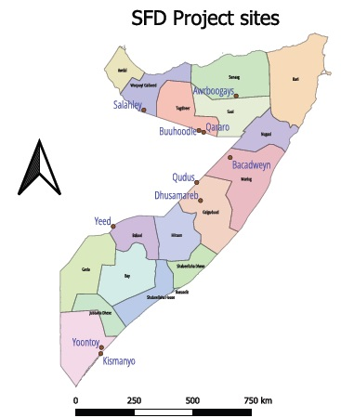
Figure: Saudi Fund for Development Project location/sites

C.3 Alignment with the National Water Resource Strategy Roadmap
Due to the complexity of the water sector challenges being faced by Somalia, both the Somalia’s National Development Plan (NDP) and the National Water Resource Strategy (NWRS) prioritize building robust and adaptive water resource management systems at different levels of the government. The proposed project is consistent with the key objectives of the NDP and the NWRS. The project actions are also in line with the sub-strategic objectives in the NWRS that underscore the importance coordinated actions across the water value chain. The project activities directly contribute to the implementation of the NWRS roadmap key priorities with a specific focus on promoting water access to the climate vulnerable pastoral and nomadic communities through scalable models rooted at local empowerment and socially inclusive approach. The project also aims to lay the foundation for strengthening of the Somali water sector management and development by providing support to both the FMS’s and local governments.

C.4 Project Objectives
Overall Goals and objectives: | The overarching goal of the project is to enhance the resilience and well-being of drought-affected communities in Somalia by ensuring sustainable access to clean water resources and fostering effective local governance of water systems. This will contribute to improved health outcomes, food security, and economic stability in regions most vulnerable to climate-induced water scarcity.  The objective of the project is to improve access to sustainable water resources for 10 drought-affected communities in Somalia through well drilling and the establishment community-owned and community-managed functioning water facilities. This objective will be achieved through a series of targeted activities including stakeholder consultations to assess local needs, the development of engineering designs and procurement processes, and the construction of boreholes with community involvement in monitoring and oversight. Further the project aims to enhance the local capacity for sustainable water governance and management by establishing participatory Operation and Maintenance (O&M) systems. This will involve conducting gender-sensitive assessments of local water demand and capacity gaps, organizing community consultations to strengthen Water Resources User Associations (WRUAs), providing technical training in O&M practices, and disseminating successful models of water governance across Somalia to enable broader replication.  The project interventions are expected to enhance the resilience of communities affected by cyclic droughts and floods, reduce water-borne diseases, and increase the availability of milk, meat, and income from livestock among pastoralists. The project will be implemented through the implementation of two interrelated outputs, outlined below:  Output 1: Access to sustainable water resources through well drilling in drought-affected communities in Somalia  Output 2: Capacity enhanced for sustainable water governance at the local level including participatory O & M system in 10 target communities.
Output 1: Improved water security through sustainable management and maintenance of water/flood control infrastructure in the target districts. | The implementation of output 1 is intended to support stakeholder consultations (Activity 1.1) to assess local needs and prepare for well drilling, including land preparation and identifying capacity gaps in operation and maintenance (O&M). Following this, the project will undertake actions to complete engineering designs and tender documents for the proposed water facilities (Activity 1.2), followed by a transparent procurement process (Activity 1.3). The culmination of this effort will result in the construction of ten water facilities through well drilling, with close supervision and community engagement (Activity 1.4).
 | Activities
 | Activity 1.1: Conduct stakeholders’ consultations at the selected drought-affected communities to validate and understand the local needs, and insights and complete the site selections including land preparation and the capacity gaps for effective O&M.
 | Activity 1.2: Mobilize actions and complete engineering design, estimate, BOQ (Bill of Quantities), and tender documents for the proposed water facility at the proposed 10 sites
 | Activity 1.3: Mobilize and complete the procurement process following an open, transparent, and competitive process.
 | Activity 1.4: Construct 10 (ten) water facilities through well drilling (boreholes), ensuring close technical supervision and participatory monitoring involving local authorities and community leaders in selected districts
Output 2: Capacity enhanced for sustainable water governance at the local level including participatory O & M system in 10 target communities. | For achieving Output 2, the project will focus on strengthening local governance of water resources. This includes conducting a technical assessment to identify local water demands and O&M capacity gaps with a gender-sensitive approach (Activity 2.1). Based on this assessment, the project will organize community consultations to establish Water Resources User Associations (WRUAs) in the target communities, ensuring inclusive governance structures (Activity 2.2). Training on effective O&M practices will be conducted to the new water facilities (Activity 2.3). Finally, the project will aim to scale successful models of water governance across Somalia through advocacy and targeted communications (Activity 2.4). Collectively, these efforts will not only address immediate water needs but also foster a framework for sustainable management and governance of water resources in the long term.
 | Activities
 | Activity 2.1: Undertake gender-sensitive technical assessment for improved understanding of (a) local water demand including household water needs (b) capacity gaps for effective Operation and Maintenance (O&M) of water structures; and (c) identify options for a commercial viable O&M cost recovery system with a clear tariff structure for domestic, livestock, and other productive uses.
 | Activity 2.2: Mobilize actions to organize local community consultations to establish/strengthen Water Resources User Associations (WRUAs) in the 10 target communities with clear terms of reference (TOR) and inclusive institutional structure to ensure conflict-sensitive, gender-responsive, and sustainable water governance at the local level, ensuring effective O&M systems for water structure.
 | Activity 2.3: Conduct technical skill-enhancing training focusing on O&M of the water facility including water pump regulations and solar system management.
 | Activity 2.4: Support scaling up actions to replicate successful models across Somalia through advocacy, awareness, and targeted communications across all levels.

- IMPLEMENTATION ARRANGEMENTS
Implementation arrangements | Implementation Arrangements: Project will be implemented under Direct Implementation Modality (DIM) of UNDP. The project locations are spread across the regions in Somalia. The project will be implemented through a multi-layered approach involving local communities, government authorities, and relevant stakeholders to ensure effective execution and sustainability. Stakeholder consultations will be facilitated local experts in collaboration with community leaders to validate local needs and identify suitable land for water facilities. Local technicians will assist in assessing capacity gaps for Operation and Maintenance (O&M). A team of engineers will be mobilized to develop the necessary engineering designs, Bill of Quantities (BoQ), and tender documents. This process will include input from local authorities to align designs with community needs. The procurement process will be conducted in compliance with open and transparent guidelines, overseen by a procurement committee composed of community representatives and technical staff to ensure accountability. Construction of the ten water facilities will occur under the supervision of experienced project engineers, with active participation from community members and local leaders to ensure that the facilities meet local standards and needs.  A gender-sensitive technical assessment will be conducted by local experts alongside community representatives to evaluate water demand and identify O&M capacity gaps. This will inform the development of a viable cost recovery system. Community consultations will be organized to establish and strengthen Water Resources User Associations (WRUAs), guided by a well-defined term of reference (TOR) to promote inclusive governance structures. Technical training sessions focusing on O&M practices will be facilitated by skilled trainers and local technicians, ensuring that community members are equipped with the necessary knowledge to manage the facilities effectively. Efforts to scale successful governance models will be led through advocacy campaigns designed to share best practices across Somalia, leveraging local media and community networks to facilitate widespread awareness and engagement. This collaborative approach involving local expertise and stakeholder participation will enhance project ownership and foster sustainable water governance in the targeted communities.
Coordination with sectoral ministries | The National Water Resource Strategy (NWRS) acknowledges that although the strategy is led by the Ministry of Energy and Water Resources (MoEWR), the involvement of various sector Ministries is crucial to achieve the strategy’s objectives. These Ministries play an essential role in the growth and development of Somalia, are reliant on water resources, and significantly impact water resources management.
Coordination with other agencies supporting the facility | The water coordination facility is currently being supported by UNDP and UNICEF, both of which are also part of the steering committee of the facility secretariat. After establishing a partnership with UNDP, MoEWR will update the facility action plan to include project activities supported by UNDP, in addition to activities supported by other agencies. This approach aims to enforce the principles of the facility, prevent duplication of efforts, ensure efficient utilization of resources, and transparently manage funding.
Reporting | The UNDP will be responsible for preparing and submitting both technical and financial progress reports to the Saudi Development Fund and other steering committee members on a yearly basis. Additionally, the final narrative and financial report will be submitted three months after the project's closure.

E. Detailed Budget
Description | Outputs and Project Main activities | Budget (USD)
Output 1: Access to sustainable water resources through well drilling in drought-affected communities in Somalia | Activity 1.1: Conduct stakeholders’ consultations at the selected drought-affected communities to validate and understand the local needs, and insights and complete the site selections including land preparation and the capacity gaps for effective O&M. | 50,000
 | Activity 1.2: Mobilize actions and complete engineering design, estimate, BOQ (Bill of Quantities), and tender documents for the proposed water facility at the proposed 10 sites. | 50,000
 | Activity 1.3: Mobilize and complete the procurement process following an open, transparent, and competitive bidding
 | Activity 1.4: Construct 10 (ten) water facilities through well drilling (boreholes), ensuring close technical supervision and participatory monitoring involving local authorities and community leaders in selected districts | 1,500,000
 | Total budget for output 1 | 1,600,000
Output2: Capacity enhanced for sustainable water governance at the local level including participatory O & M system in 10 target communities. | Activity 2.1: Undertake gender-sensitive technical assessment for improved understanding of (a) local water demand including household water needs (b) capacity gaps for effective Operation and Maintenance (O&M) of water structures; and (c) identify options for a commercially viable O&M cost recovery system with a clear tariff structure for domestic, livestock, and other productive uses. | 30,000
 | Activity 2.2: Mobilize actions to organize local community consultations to establish/strengthen Water Resources User Associations (WRUAs) in the 10 target communities with clear terms of reference (TOR) and inclusive institutional structure to ensure conflict-sensitive, gender-responsive, and sustainable water governance at the local level, ensuring effective O&M systems for water structure. | 60,000
 | Activity 2.3: Conduct technical skill-enhancing training focusing on O&M of the water facility including water pump regulations and solar system management. | 30,000
 | Activity 2.4: Support scaling up actions to replicate successful models across Somalia through advocacy, awareness, and targeted communications across all levels. | 30,000
 | total budget for output 2 | 150,000
 | Total 3 outputs | 1,750,000
Project Management Unit | Project Manager (national) for 18 Months (80,000)  Project Engineer – 1 for 18 months (70,000) | 150,000
GMS |  | 100,000
Total Budget |  | 2,000,000.00

- MONITORING AND EVALUATION FRAMEWORK
Monitoring: In accordance with the programming policies and procedures outlined in the UNDP monitoring policy, a detailed monitoring shall be developed upon approval of the project. The project contributes to multiple indicators across the CPD. UNDP has an M&E working group and consolidated data from the project will be reviewed and discussed during quarterly working group meetings. Indicator tracking will be done through both project staff and third-party monitoring utilizing observations and spot-checks.
Expected Results (Outputs & activities)  Output 1: Access to sustainable water resources through well drilling in drought-affected communities in Somalia. | Baseline | Indicators | Targets | Data Source  How will it be measured? | Freq.  How often will it be measured? | Responsibilities  Who will measure it? | Reporting  Where will it be reported?
Activity 1.1: Conduct stakeholders’ consultations at the selected drought-affected communities to validate and understand the local needs, and insights and complete the site selections including land preparation and the capacity gaps for effective O&M. | 0 | Indicator 1.1: Number of stakeholder consultations conducted. | 10 | Consultation meeting minutes; Participant feedback surveys. | At least one time | Project Manager / Coordinator; Project; independent evaluators; third-party monitoring; M&E team. | Monthly progress reports; Evaluation report; government reports.
Activity 1.2: Mobilize actions and complete engineering design, estimate, BOQ (Bill of Quantities), and tender documents for the proposed water facility at the proposed 10 sites. | 0 | Indicator 1.2: Number of engineering designs completed. | 10 | Design documents and technical reports; Bill of Quantities (BOQ) documentation; Project reports: assessments report; stakeholder consultation report. | At least one time | Engineering Team Lead; Procurement team; independent evaluators; third-party monitoring; M&E team | Final design report; Project reports; Evaluation report; government reports
Activity 1.3: Mobilize and complete the procurement process following an open, transparent, and competitive process. |  | Indicator 1.3: Number of tenders issued. | 10 | Procurement records; Tender documents and submissions | At least one time | Procurement team; Project team | Final procurement report; Monthly progress reports; Evaluation report; government reports.
Activity 1.4: Construct 10 (ten) water facilities through well drilling (boreholes), ensuring close technical supervision and participatory monitoring involving local authorities and community leaders in selected districts. |  | Indicator 1.4: Number of water facilities constructed. | 10 | Construction progress reports; Post-construction surveys. | At least one time | Construction Engineer / Manager; Project team. | Construction reports; Final evaluation report assessing community impact; Monthly progress reports; procurement report;
Output 2: Capacity enhanced for sustainable water governance at the local level including participatory O & M system in 10 target communities. | Baseline | Indicators | Targets | Data Sources | Freq | Responsible | Reporting
Activity 2.1: Undertake gender-sensitive technical assessment for improved understanding of (a) local water demand including household water needs (b) capacity gaps for effective Operation and Maintenance (O&M) of water structures; and (c) identify options for a commercial viable O&M cost recovery system with a clear tariff structure for domestic, livestock, and other productive uses. | 0 | Indicator 2.1: Number of gender-sensitive assessments conducted. | 1 | Project reports; Assessment reports; Household surveys; Community focus group discussions; BOQs. Designs; Work done Engineering Certificates | At least on bi-annual basis. | Project; independent evaluators; third-party monitoring; M&E team. | Project reports; Evaluation report; government reports; Final report at project completion.
Activity 2.2: Mobilize actions to organize local community consultations to establish/strengthen Water Resources User Associations (WRUAs) in the 10 target communities with clear terms of reference (TOR) and inclusive institutional structure to ensure conflict-sensitive, gender-responsive, and sustainable water governance at the local level, ensuring effective O&M systems for water structure. | 0 | Indicator 2.2: Number of WRUAs established or strengthened. | 10 | Project reports; Meeting minutes and attendance records; TOR documents for WRUAs. | At least on bi-annual basis | Project; independent evaluators; third-party monitoring; M&E team | Project reports; Evaluation report; government reports
Activity 2.3: Conduct technical skill-enhancing training focusing on O&M of the water facility including water pump regulations and solar system management. | 0 | Indicator 2.3: Number of training sessions conducted. | 10 | Project reports; Training attendance sheets; Pre- and post-training evaluation surveys. | At least on bi-annual basis | Project; independent evaluators; third-party monitoring; M&E team | Project reports; Training reports; Evaluation report; government reports
Activity 2.4: Support scaling up actions to replicate successful models across Somalia through advocacy, awareness, and targeted communications across all levels. | 0 | Indicator 2.4: Number of advocacy campaigns conducted. | 3 | Project reports; Meeting minutes and attendance records; | At least on bi-annual basis | Project; independent evaluators; third-party monitoring; M&E team | Project reports; Campaign reports; Evaluation report; government reports

- Communication and Visibility
The project will dedicate its focus and attention to transparently promoting Saudi contributions as part of UNDP's ongoing partnership and ensuring their recognition in all relevant spaces, events, and actions. To this end, a communication and visibility plan has been developed for implementation, which is attached as an annex to this proposal.

Sustainability, Scaling Up and Exist Strategy
UNDP stands as a credible partner in mobilizing actions to scale up drought response and recovery, fulfilling distinct roles within the Inter-Agency Standing Committee (IASC), alongside partner UN agencies, civil society, and the international community. Its credibility is enhanced by its position as a knowledge frontier organization within the UN Development System, where it acts as an integrator of collective action aimed at achieving the Sustainable Development Goals (SDGs). Additionally, UNDP plays a pivotal role in promoting the Humanitarian-Development-Peace Nexus and employs area-based portfolio systems to ensure coordinated, resilient, and inclusive recovery and disaster risk management during humanitarian crises and conflict-affected situations. This project effectively unites various units within the country office, amplifying the efficiency and impact of project activities. UNDP’s extensive experience operating at multiple government levels and across diverse sectors underscores its capacity to drive comprehensive approaches, empowering local communities and fostering peacebuilding efforts.
At the intervention sites, local community members, both men and women, will receive gender-sensitive capacity development training focused on the effective use and maintenance of water infrastructure. Training materials will be provided in the local language, ensuring accessibility and practical relevance. The water access points established for agropastoral, and pastoralist communities will serve as critical assets, significantly boosting water security. Enhanced access to water is anticipated to improve livestock well-being, which in turn will lead to increased agricultural production and improved livelihoods for pastoralists. This tangible benefit will incentivize community members to take ownership of these structures and invest in their long-term maintenance. Training will encompass best practices in equipment usage and maintenance, ensuring the sustainability of these resources.
UNDP is committed to disseminating its plans, results, and lessons learned to key donors engaged in Somalia who have strategic interests in enhancing community resilience. This effort aims to expand access to diversified funding sources, thereby scaling up the project and encouraging the replication of successful approaches in other regions of Somalia facing similar challenges, particularly regarding drought response and stabilization efforts.
Local ownership and leadership are critical to ensuring sustainability. Facilitating inclusive dialogue through community consultation forums will foster trust and create a conducive environment for development. This participatory approach is likely to yield sustainable outcomes by bolstering local resilience against both conflict and climate shocks. UNDP will actively explore opportunity and engage with the donors to mobilize investments that will enable the replication of this successful model in additional communities and districts, reinforcing the overall goal of sustainable development.
- Stakeholder, Beneficiary Engagement, youth and Gender Strategy
The project aims to benefit 10 selected communities in Somalia that have been affected by drought. It will directly impact 120,000 people who are vulnerable to climate-related challenges by providing year-round and sustainable access to water. Over 3 million drought affected climate vulnerable people will be indirectly benefitted with good practices of water access, improved awareness and understanding on sustainable management of water resources at the community level. The project specifically targets vulnerable groups, including women-headed households, persons with disabilities, internally displaced persons, youth, and marginalized communities affected by drought and climate change. Key stakeholders involved will include state and local governments, civil society organizations, women's groups, faith-based organizations, elders, religious scholars, academia, and the private sector. The project will prioritize the inclusive participation of groups that are typically excluded and ensure effective consideration of gender concerns in water governance at the community level. The UNDP Gender Adviser will play a key role in project implementation by coordinating and enhancing the capabilities of partners at the federal and local levels. This will involve facilitating the collection of disaggregated data, conducting gender analysis, and establishing gender-disaggregated baselines for effective monitoring and evaluation purposes.
Risks and Assumptions
There are several risks associated with operating in conflict areas with vulnerable. The project will look and mitigate the potential associated risk during the project implementation:
- The first principle is to ensure that the project leaves no one behind, is conflict-sensitive and does no harm. It requires the team to have a deeper understanding of the political economy through proper stakeholder mapping and analysis of shifting power dynamics.
- High turnover and changes in government counterparts can affect project implementation and coordination if previous commitments come under question. Therefore, it is important that agreements shall be institutionalized and involving broad government participation beyond single individuals.
- The project will use adaptive management approach to addressing emerging challenges and evolving needs, and to ensure continuous monitoring of the context through engagement with the authorities and beneficiaries to make swift adaptations to activities, targets, or implementation modalities. also to ensure results are achieved as soon as evidence suggests this to be necessary.
- Remote project management carries risks, but UNDP will ensure that national staff lead project implementation as well as engage closely with 3rd party monitoring partners.

- Project Management

The Project Team is responsible for day-to-day project management and regular monitoring of project results and risks, including social and environmental risks. The project team will ensure that all project staff maintain a high level of transparency, responsibility and accountability in M&E and reporting of project results. The Project team will inform UNDP Country Office and the Donor and of any delays or difficulties as they arise during implementation so that appropriate support and corrective measures can be adopted.

Project Workplan
The project activities will take place between October 2024 – March 2026.
Description | Outputs and Project Main activities | Oct 2024  Q4 | Jan 2025  Q1 | Apr 2025  Q2 | July 2025  Q3 | Oct 2025  Q4 | Jan 2026  Q1
Output 1: Access to sustainable water resources through well drilling in drought-affected communities in Somalia | Activity 1.1: Conduct stakeholders’ consultations at the selected drought-affected communities to validate and understand the local needs, and insights and complete the site selections including land preparation and the capacity gaps for effective O&M.
 | Activity 1.2: Mobilize actions and complete engineering design, estimate, BOQ (Bill of Quantities), and tender documents for the proposed water facility at the proposed 10 sites.
 | Activity 1.3: Mobilize and complete the procurement process following an open, transparent, and competitive process.
 | Activity 1.4: Construct 10 (ten) water facilities through well drilling (boreholes), ensuring close technical supervision and participatory monitoring involving local authorities and community leaders in selected districts.
Output 2: Capacity enhanced for sustainable water governance at the local level including participatory O & M system in 10 target communities. | Activity 2.1: Undertake gender-sensitive technical assessment for improved understanding of (a) local water demand including household water needs, (b) capacity gaps for effective Operation and Maintenance (O&M) of water structures; and (c) identify options for a commercially viable O&M cost recovery system with a clear tariff structure for domestic, livestock, and other productive uses.
 | Activity 2.2: Mobilize actions to organize local community consultations to establish/strengthen Water Resources User Associations (WRUAs) in the 10 target communities with clear terms of reference (TOR) and inclusive institutional structure to ensure conflict-sensitive, gender-responsive, and sustainable water governance at the local level, ensuring effective O&M systems for water structure.
 | Activity 2.3: Conduct technical skill-enhancing training focusing on O&M of the water facility including water pump regulations and solar system management.
 | Activity 2.4: Support scaling up actions to replicate successful models across Somalia through advocacy, awareness, and targeted communications across all levels.

Annex-I : Beneficiary Estimations
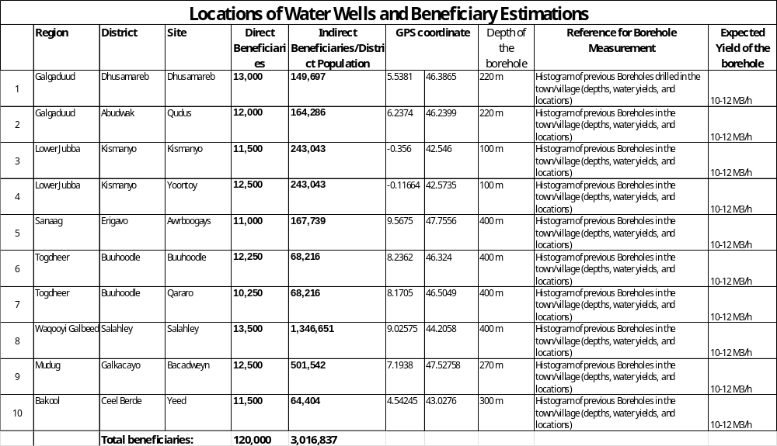

Annex-2: Sample Technical Drawings
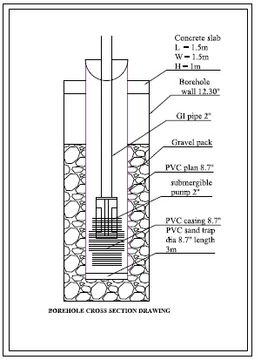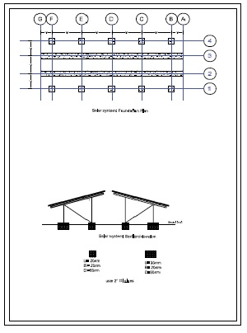
SAMPLE DRAWINGS OF WELL DRILLING (BOREHOLE) & SOLAR SYSTEM

Annex-III : Communication and Visibility Plan
A- Objectives
1. Overall communication objective
The primary communication objective is to generate positive coverage for the project, its donors, and UNDP among key stakeholders by leveraging all available channels within UNDP Somalia, as well as regional and headquarters platforms and networks.

The project communications will focus on the following key areas: (a) articulating the issues and needs on the ground; (b) highlighting the project's impact and progress; and (c) positioning UNDP and SFD as primary partners to both the government and the people of Somalia.

This communication plan will serve as tool for engaging directly and indirectly with beneficiaries, host communities, various government levels, and other relevant audiences, including the diaspora and development partners. Recognizing the diverse demographics of our target audiences, the communication plan will employ tailored communication tools developed in close consultation with UNDP and SFD.

2. Target groups
Communication target groups include:
- Local stakeholders, direct and indirect beneficiaries and general public in Somalia
- Local and international media
- Policy makers, influencers and civil society inside Somalia
- Development partners and practitioners in this area
- Media, including local, regional, and international media outlets.
- Donor community, including donor countries and organizations supporting Somalia.
- Diaspora community

3. Specific objectives for target groups
- RAISE awareness/profile: Continue to raise awareness of SFD and UNDP support amongst the international community and user groups on the key results of the project
- INCREASE online audience engagement: Ensure improved audience/stakeholder engagement via social media across all social media platforms using theme-based posts and developing specific ones highlighting SFD support to the climate vulnerable, drought affected water-stressed communities in Somalia.
- SHAPE the narrative: Influence the conversation, shape the narrative around SFD’s support to well drilling and rural development programme in Somalia, empowering drought affected communities with access to water and sustainable water governance at the local level.

B- Communication Activities
- Issuing press releases, sharing human interest stories, and creating photo stories highlighting the positive results achieved through the partnership of SFD and UNDP.
- The SFD and UNDP logos will be prominently displayed on supplies and other materials such as banners to raise awareness among the end beneficiaries about the contributions of the Saudi Fund for Development.
- UNDP will utilize its social media platforms, such as Facebook and Twitter, to disseminate information on the project's results while ensuring that the people of Saudi Arabia's contribution is duly recognized.
- UNDP will explore opportunities and promote close engagement with the Embassy of The Kingdom of Saudi Arabia, including regular communication and joint field visits where possible.

